2020 02 07 NR Daily Log

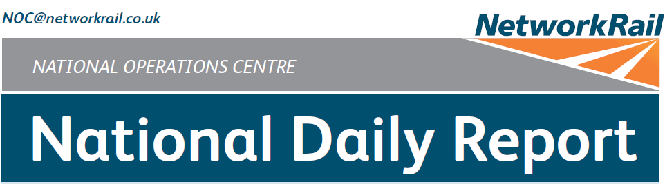



***DATE OF REPORT: NOC MANAGER 0700 – 1900:***

***NOC MANAGER 1900 – 0700:***

***DUTY CONTROLLER 0630 – 1830:***

***DUTY CONTROLLER 1830 – 0630:***

***SUPPORT CONTROLLER 0630 – 1830:***

***SUPPORT CONTROLLER 1830 – 0630:***

***LONDON CONTROLLER 0700 – 1900:***

***LONDON CONTROLLER 1900 – 0700:***

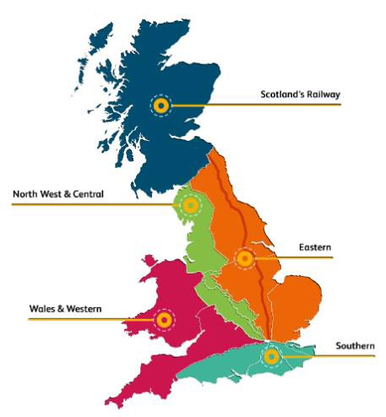

Friday 7th February 2020 Lucinda Wing

Matthew Whitfield Robert Scoot Mark Robinson Pete Ure

Jo Billson Dominic Duggan Keith Stokes

Page 2 of 1

5

|  |  |  |
| --- | --- | --- |
|  | ***TABLE OF CONTENTS*** |  |
| ***01*** | ***WRONG SIDE FAILURE REPORTS*** | ***3*** |
| ***02*** | ***SIGNALS PASSED AT RED (CATEGORY ‘A’)*** | ***3*** |
| ***03*** | ***DERAILMENTS*** | ***3*** |
| ***04*** | ***COLLISIONS*** | ***4*** |
| ***05*** | ***TRAIN OR VEHICLE RUNAWAY*** | ***4*** |
| ***06*** | ***OPERATIONAL INCIDENTS*** | ***4*** |
| ***07*** | ***TRAINS WITH STRANDED PASSENGERS*** | ***5*** |
| ***08*** | ***SIGNIFICANT POSSESSION PROBLEMS*** | ***5*** |
| ***09*** | ***FATALITIES*** | ***5*** |
| ***10*** | ***INJURIES/ASSAULTS*** | ***5*** |
| ***11*** | ***NEAR MISSES*** | ***5*** |
| ***12*** | ***RAILWAY CRIME*** | ***6*** |
| ***13*** | ***STATION OVERRUNS*** | ***6*** |
| ***14*** | ***BROKEN RAILS/TRACK DEFECTS*** | ***7*** |
| ***15*** | ***POWER FAILURES*** | ***7*** |
| ***16*** | ***POINTS FAILURES*** | ***7*** |
| ***17*** | ***SIGNALS/SIGNALLING SYSTEMS FAILURES*** | ***7*** |
| ***18*** | ***TRACK CIRCUIT & AXLE COUNTER FAILURES*** | ***8*** |
| ***19*** | ***BRIDGE STRIKES*** | ***9*** |
| ***20*** | ***ROAD VEHICLE INCURSIONS (NON-LEVEL CROSSINGS)*** | ***9*** |
| ***21*** | ***TRACTION FAILURES*** | ***9*** |
| ***22*** | ***WEATHER-RELATED PROBLEMS*** |  |
| ***10*** |  |  |
| ***23*** | ***FIRES*** |  |
| ***10*** |  |  |
| ***24*** | ***WILD REPORTS & HABD ACTIVATIONS*** |  |
| ***10*** |  |  |
| ***25*** | ***GROUP STANDARDS GE/RT8250 & GO/RT3350*** |  |
| ***12*** |  |  |
| ***26***  ***12*** | ***TPWS*** |  |

***27***

***MISCELLANEOUS***

***12***

***28***

***REVIEW TABLE***

***13***

***29***

***REAL TIME PERFORMANCE FIGURES***

***14***

***01 WRONG SIDE FAILURE REPORTS***

None.

***02 SIGNALS PASSED AT RED (CATEGORY ‘A’)***

None.

***03 DERAILMENTS***

## Eastern (Anglia) – CCIL 2090096 / Fault No.304918

At 0144, the SCO:24/7 Duty Manager reported that Balfour Beatty Tamper DR75409 had derailed within engineer’s possession as per AR WON 45, Item 278, various lines including Beccles – Oulton Broad North Junction, Up and Down East Suffolk line blocked 0025 (Mon) – 2359 (Fri), a Network Operations Anglia managed possession. The tamper became derailed by two bogies on No.12A points at Oulton Broad North Junction. There were no injuries reported. BRUFF were requested to attend and gave an ETA of 0530. There was damage to twelve sleepers, 20 chairs and 20 keys that all required replacement. Initial investigations revealed that the rodding from the points had been removed by a member of staff and they had not reapplied the clip, scotch and padlock. Two members of staff, the Engineering Supervisor and their support staff were relieved of duty for ‘for cause’ screening. BRUFF arrived on site at 0545. An Investigating Officer was appointed. The original BRUFF team were out of hours before rerailing had been completed with a replacement team attending, with an ETA of 1200. By 1325 the majority of the track damage had been repaired. Rerailing and track damage was completed by 1625 with the affected tamper removed from site. The points have been secured and will be repaired within the possession.

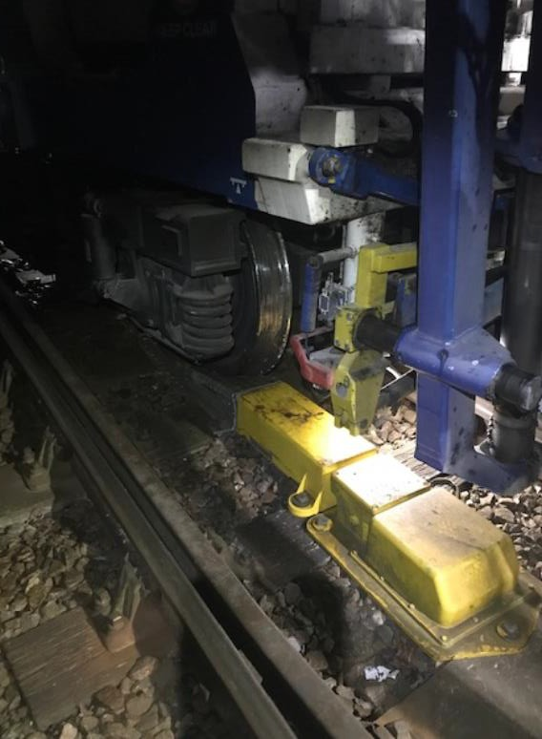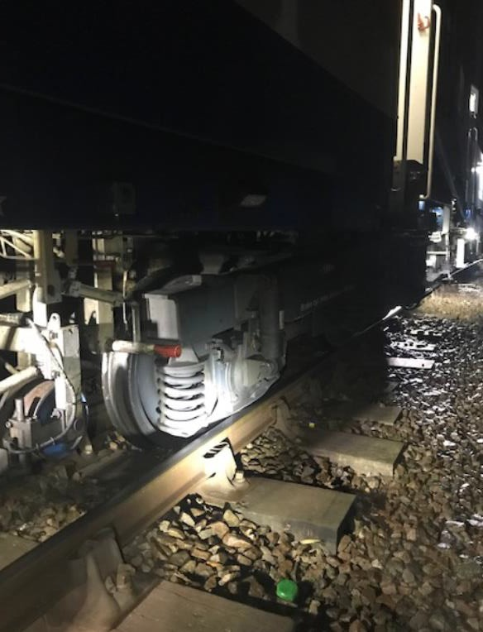

## Eastern (East Coast) - CCIL 2090188 / Fault No. 786818

At 0719, the driver of 5F46, Northern, 0618 Leeds Holbeck Sidings – Goole, reported that they had observed that 6X95, DB Cargo, Scunthorpe – Goole Docks had derailed on the shunt spur within the sidings at Goole Docks. DB Cargo advised at 0737 that the last bogie of the rear wagon, IGA 8046470260 by consist, had derailed. A Mobile Operations Manager arrived on site at 0759 and confirmed at 0840 that the derailment had occurred on NR infrastructure. The cause was due to 6X95 propelling towards and colliding with the buffer stops on the No. 2 Shunt Spur. DB Cargo arranged for the driver of 6X95 to be ‘for cause’ screened. The Wigan BRUFF team were requested to attend, arriving on site at 1437. Work to re- rail the wagon commenced at 1738 and was completed by 1832. The Mobile Operations Manager confirmed that the No. 2 Shunt Spur had been secured out of use pending repairs, and that the Loop had reopened. Traffic for Goole Docks has been suspended until Thursday 13/02/20.

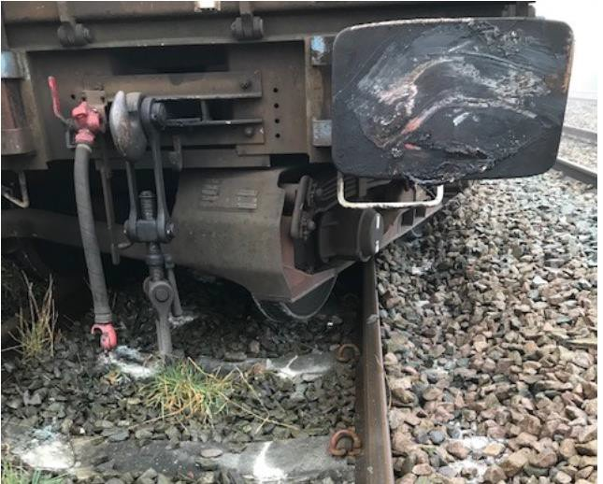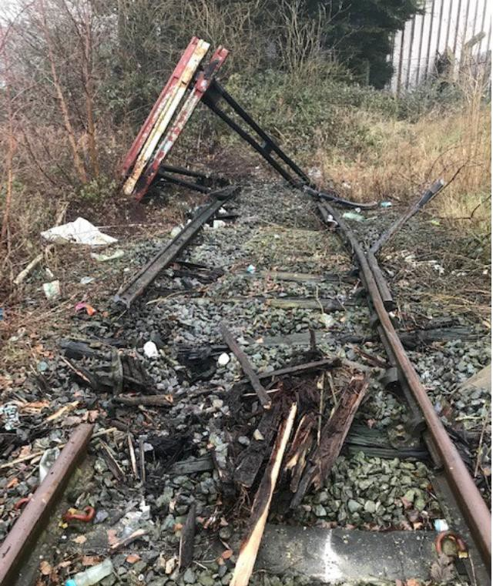

|  |  |  |  |  |  |  |  |
| --- | --- | --- | --- | --- | --- | --- | --- |
| TRUST 759998 FWAM | | | | | | | |
| Cancelled | 0 | Part Cancelled | 0 | Trains Delayed | 1 | Minutes | 22 |

***04 COLLISIONS***

See section **03** of this Report for a Buffer Stop Collision at Goole Sidings.

***05 TRAIN OR VEHICLE RUNAWAY***

None.

***06 OPERATIONAL INCIDENTS***

## Eastern (East Coast – CCIL 2090440

At 1603 Govia Thameslink Railway reported that 9S34, Govia Thameslink Railway, 1338 Brighton – Cambridge formed by unit 700121 comprising 12 coaches, had stopped at the 8 instead of the 12 car marker at Letchworth station. This was reported via a passenger on a helpline to Govia Thameslink Railway. Govia Thameslink Railway checked the CCTV and confirmed the incident. The CCTV did not confirm if the doors off the platform were opened and the driver did not report the incident. No passenger incidents were reported. The information was not known in time to stop the train at a suitable location. The driver was met by a manager upon arrival at Cambridge. GTR informed the signaller, who confirmed they had not been notified. The driver was relieved of duty and ‘for cause’ screened.

|  |  |  |  |  |  |
| --- | --- | --- | --- | --- | --- |
| ***Region / Route*** | ***Train*** | ***Since*** | ***Between*** | ***OUTCOME*** | ***CCIL*** |
| Wales and  Western / Western | 2C87, Great Western Railway, 1800 Cardiff Central - Penzance | 1920 -  2000 | Yatton and Worle | Train on the move after trespasser apprehended. | 2090507 |
| Scotland | 1S36, Avanti West Coast, 0616 Birmingham New Street – Edinburgh Waverley | 0959 -  1104 | Auchengray – Midcalder Jn | Trapped after a track circuit failure at Slateford, on the move after track circuit cleared and route set by signaller. | 2090150 |
| Scotland | 1V58, CrossCountry, 0900  Glasgow Central - Penzance | 0943 -  1106 | Midcalder Junction - Slateford | Trapped after a track circuit failure at Slateford, on the move after track circuit cleared and route set by signaller. | 2090150 |
| Scotland | 1Y76, ScotRail, 0904 Glasgow Central – Edinburgh Waverley | 0952 -  1110 | Midcalder Junction - Slateford | Trapped after a track circuit failure at Slateford, on the move after track circuit cleared and route set by signaller. | 2090150 |
| Scotland | 2Y48, ScotRail, 0917 Glasgow Central – Edinburgh Waverley | 1018 -  1113 | Livingston South – Midcalder Jn | Trapped after a track circuit failure at Slateford, on the move after track circuit cleared and route set by signaller. | 2090150 |
| North West and Central (WCMLS | 1A46, Avanti West Coast, 1455 Manchester Piccadilly – London Euston | 1543 -  1630 | Stafford - Colwich | Trapped by points failure until S&T attended. | 2090434 |
| Wales and  Western / Western | 2U28, Great Western Railway, 1808 Taunton – Cardiff Central | 1907 –  1952 | Weston Milton and Worle | Train on the move after trespasser apprehended. | 2090507 |
| Wales and  Western / Western | 1V62, CrossCountry, 1100  Glasgow Central - Penzance | 1907 -  1956 | Yatton and Worle | Train on the move after trespasser apprehended. | 2090507 |

***08 SIGNIFICANT POSSESSION PROBLEMS***

None.

***09 FATALITIES***

None.

***10 INJURIES/ASSAULTS***

## North West and Central (NW) – CCIL 2090049

At 0015 (Thu) it was reported that a member of track staff had sustained an injury to their groin area after tripping over old cable at Parton. The staff member was conveyed to hospital and had their injuries assessed. The staff member was discharged from hospital with pain medication.

***11 NEAR MISSES***

## Eastern (EM) – CCIL 2090489

At 1745 the driver of 0R58, Rail Operations Group, 1559 Worksop - Leicester, reported a near miss at Pinxton CCTV Level Crossing between Kirby Junction and Ironville Junction with a dog walker using the crossing. The driver sounded their horn and came to a stand after making an emergency braking application one locomotive from the individual. The person was then observed to leave the crossing. The driver was fit to continue. A Mobile Operations Manager attended, reporting at 2144 that all crossing equipment was in order. The BT Police (ref. 458) were advised.

## Southern (Sussex) – CCIL 2090500

At 1830 the driver of 2B13, Govia Thameslink Railway, 1809 Epsom Downs – London Victoria, retrospectively reported a near miss on their previous working 2B02, Govia Thameslink Railway, 1700 London Victoria – Epsom Downs at Belmont with a youth that attempted to surf on the side of the train. The person jumped back onto the platform after the driver had shouted at them. The driver was shaken by the incident but was fit to continue. CCTV footage was interrogated which substantiated the drivers report. The EIU confirmed the area clear at 1928.

***12 RAILWAY CRIME***

## North West and Central (C) – CCIL 2090301

At 1019, the driver of 1S39, CrossCountry, 0627 Plymouth – Glasgow Central, reported a person sitting on the track at Tamworth Viaduct. Two Mobile Operations Managers were requested to site at 1025. Staffordshire Police reported at 1032 that the area was clear, but trains were instructed to run at extreme caution. However, at 1051 West Midlands Signalling Centre reported that the person was now sitting in the six foot refusing to move. In response, all lines were blocked, with some services were diverted via the Cross City line. The BT Police Embedded Inspector (ref. 152), reported at 1117 that the person was the wrong side of the parapet on the viaduct and was threatening to jump onto Amington Road should anyone approach them. A negotiator was requested to site. Staffordshire Police and the BT Police were on site with the person at 1118, with a working at heights team mobilised to site. By 1152, the person had been coaxed down and all personnel were clear of the lines, thus allowing train running to resume.

|  |  |  |  |  |  |  |  |
| --- | --- | --- | --- | --- | --- | --- | --- |
| TRUST 759147 XQEB | | | | | | | |
| Cancelled | 3 | Part Cancelled | 9 | Trains Delayed | 216 | Minutes | 2389 |

## Wales and Western (Western) – CCIL 2090507

At 1907 the driver of 1C22, Great Western Railway, 1632 London Paddington – Taunton, reported a trespasser lineside between Worle Junction and Weston Milton on the Single line. 2U28, Great Western Railway, 1808 Taunton – Cardiff Central was utilised to examine the line, with the driver reporting at 1915 that they had come to a stand on the Single line approaching Worle Junction as the person was in front of the service. Multiple services were trapped, two of which were outside of station (detailed in section **07** of this Report), with the Bristol Mobile Operations Manager, Avon & Somerset Police (ref. 977) and the BT Police (ref. 504) all mobilised to site. The guard of 2U28 remained with the person until response staff arrived on site. By 1940 the person had been apprehended, with trains signalled normally from 1948 after it was confirmed that all personnel were clear of the line.

|  |  |  |  |  |  |  |  |
| --- | --- | --- | --- | --- | --- | --- | --- |
| TRUST 760709 XQDZ | | | | | | | |
| Cancelled | 0 | Part Cancelled | 2 | Trains Delayed | 26 | Minutes | 526 |

***13 STATION OVERRUNS***

## Southern (Kent) – CCIL 2090454

At 1600 2U58, Southeastern, 1550 Gravesend – London Victoria, formed by unit 465249 & 465164, comprising eight coaches in all, overran Greenhithe for Blue Water station by half a metre, returning to the station was not authorised. The driver stated that the overrun was due to misjudging the braking distance, with the service terminated and driver relieved of duty on arrival at Dartford.

|  |  |  |  |  |  |  |  |
| --- | --- | --- | --- | --- | --- | --- | --- |
| TRUST 759961 THUV | | | | | | | |
| Cancelled | 1 | Part Cancelled | 1 | Trains Delayed | 6 | Minutes | 21 |

## North West and Central (C) – CCIL 2090487

At 1743 1W51, Chiltern, 1734 Marylebone – High Wycombe, formed by units 165002 & 165027, comprising four coaches in all, overran Wembley Stadium station by two coach lengths, returning to the station was not authorised. The driver stated that the overrun was due to misreading the diagram and believed their first stop was Gerrards Cross. The driver was fit to continue.

|  |  |  |  |  |  |  |  |
| --- | --- | --- | --- | --- | --- | --- | --- |
| TRUST 760223 THOB | | | | | | | |
| Cancelled | 0 | Part Cancelled | 0 | Trains Delayed | 7 | Minutes | 60 |

***14 BROKEN RAILS/TRACK DEFECTS***

None.

***15 POWER FAILURES***

None.

***16 POINTS FAILURES***

## Southern (Wessex) – CCIL 2090263 / Fault No. 463041.

At 0905 the signaller at Basingstoke ASC reported a loss of detection on No. 2534A points at Basingstoke, affecting the Up Slow line. A Mobile Operations Manager and S&T staff were sent to site. The fault caused 4O23, GB Railfreight, to be held at BE163 signal in platform 2 at Basingstoke station, with the rear of the train straddling Great Western Junction, preventing movements to/from Reading. Trains were authorised past affected signals at red, with trapped trains worked into platforms. Access was granted to S&T staff to conduct an initial investigation which revealed a defective ECU as the issue. A replacement ECU was sourced from the stores, with the Mobile Operations Manager securing the points, allowing 4O23 to proceed at 0945 which released the Reading route. The ECU was replaced, with trains signalled normally from 1058 after all testing had been completed.

|  |  |  |  |  |  |  |  |
| --- | --- | --- | --- | --- | --- | --- | --- |
| TRUST 759190 IQCZ | | | | | | | |
| Cancelled | 8 | Part Cancelled | 14 | Trains Delayed | 228 | Minutes | 2933 |

## North West and Central (C) – CCIL 2090420 / Fault No. 881110

At 1515 the driver of 1Y47, Chiltern, 1411 Oxford - Marylebone, reported that ME34 signal on the Up Main line at Neasden South Junction had reverted from green to red as the train approached. The driver was unable to stop and passed the signal at red. There reason for the reversion was due to ME835B points momentarily losing detection. The driver was fit to continue.

|  |  |  |  |  |  |  |  |
| --- | --- | --- | --- | --- | --- | --- | --- |
| TRUST 759858 IQEB | | | | | | | |
| Cancelled | 0 | Part Cancelled | 0 | Trains Delayed | 48 | Minutes | 133 |

***17 SIGNALS/SIGNALLING SYSTEMS FAILURES***

None.

## Scotland CCIL 2090150 / Fault No. 349169

At 0330, the Shift Signalling Manager at Edinburgh IECC, reported that track circuit ‘787’ on the Up Branch line in Slateford sidings had failed. S&T were on site at 0420 but were unable to find a fault. At 0617, the Shift Signalling Manager advised that they were unable to clear ES686 signal on the Up Midcalder line at Slateford. A P’Way Section Manager was on site at 0702 and was granted a Line Blockage at 0726 to investigate. A dead short in the track was identified with track circuit ‘787’ still showing failed at 0818. By 1045, the track circuit had gone clear, allowing train running to resume. A defective IBJ was identified and stripped and cleaned, with the fault placed in order at 1427.

|  |  |  |  |  |  |  |  |
| --- | --- | --- | --- | --- | --- | --- | --- |
| TRUST 758381 IQLE | | | | | | | |
| Cancelled | 2 | Part Cancelled | 2 | Trains Delayed | 25 | Minutes | 137 |

|  |  |  |  |  |  |  |  |
| --- | --- | --- | --- | --- | --- | --- | --- |
| TRUST 739869 IQLE (since 31/01/20) | | | | | | | |
| Cancelled | 8 | Part Cancelled | 7 | Trains Delayed | 105 | Minutes | 1483 |

## Eastern (Anglia) – CCIL 2090189/ Fault No. 304924

At 0659 “HAE” axle counter on the Up North London line at Kentish Town failed, holding NL1206 signal at red. Services were authorised past the affected signal and S&T staff were sent to site. Service levels were reduced to ease congestion, with some services running fast to recover lost time. A system reset by the signaller failed to clear the fault. S&T staff replaced the parallel card with a reconditioned card at 0732 but this failed to overcome the fault. A new card was then installed, clearing the fault at 0744.

|  |  |  |  |  |  |  |  |
| --- | --- | --- | --- | --- | --- | --- | --- |
| TRUST 758588 IQHP | | | | | | | |
| Cancelled | 9 | Part Cancelled | 35 | Trains Delayed | 65 | Minutes | 982 |

## Southern (Sussex) – CCIL 2090241 / Fault No. 159066

At 0752 the Shift Signaller Manager at the Three Bridges ASC reported that axle counters “MJM” and “MJN” on the Down Arun Valley line at Pulborough had failed. Services were authorised past affected signals at red. A Mobile Operations Manager and S&T staff were sent to site with service levels reduced. At 0944 the Mobile Operations Manager reported finding blue temporary fencing wrapped around the axle counter heads. At 0957 axle counters “MKH” and “MKJ” on the Up Arun Valley line also failed. The temporary fencing was removed and the axle counter cards re-seated by 1023. The Down line was restored at 1044 and the Up line at 1048. The Mobile Operations Manager undertook an inspection of the surrounding area to highlight any potential loose equipment/fencing that may cause an issue in relation to the high winds forecast for the weekend.

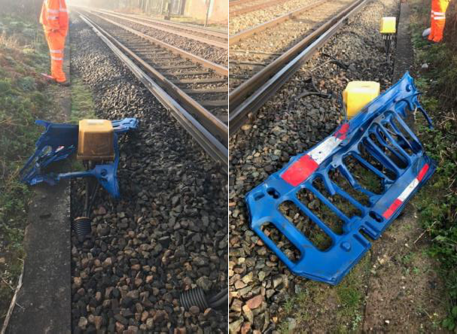

|  |  |  |  |  |  |  |  |
| --- | --- | --- | --- | --- | --- | --- | --- |
| TRUST 758865 IQBG | | | | | | | |
| Cancelled | 3 | Part Cancelled | 19 | Trains Delayed | 53 | Minutes | 548 |

## Eastern (East Coast) – CCIL 2090448 / Fault No. 786891

At 1625, No.3311 track circuit on the Down Fast line at Hitchin failed holding K713 signal at red. 1D21, London North Eastern Railway, 1603 London King’s Cross - Leeds examined the line from the Down Slow line and reported that K711 signal was also held at red but observed no issues with the related track circuit and services continued to be cautioned. S&T staff were on site at 1659 and were afforded a ten minute Line Blockage of the Down Fast line at 1713. By 1746 S&T staff had identified a burnt out transformer in Location Cabinet 54/35 which required replacing, and a replacement part was sourced. Service revisions were imposed as per Contingency Plan KX QUEBEC ONE BRAVO. By 1840, the faulty transformer had been replaced and the track circuit was placed in order, thus allowing services to be signalled normally.

|  |  |  |  |  |  |  |  |
| --- | --- | --- | --- | --- | --- | --- | --- |
| TRUST 760027 IQI8 | | | | | | | |
| Cancelled | 2 | Part Cancelled | 1 | Trains Delayed | 118 | Minutes | 983 |

## Eastern (EM) – CCIL 2090505 / Fault No. 153984

At 1846, ‘134’ track circuit on the Up Moorgate line at Kentish Town failed holding WH420 signal at red. Services were signalled via platform 3 or terminated short of destination where possible to ease congestion, with some services run fast. 9R47, Govia Thameslink Railway, 1740 Bedford – Gatwick Airport was utilised to examine the line, reporting at 1853 nothing amiss, but the track circuit remained in a failed state. A Mobile Operations Manager was on site at 1915 and was afforded a ten minute Line Blockage from 1940, reporting that they could see no obvious issues. The Night turn S&T were on site from 2005, and by 2136 had identified a faulty ETU. Investigations continued overnight at the close of this report.

|  |  |  |  |  |  |  |  |
| --- | --- | --- | --- | --- | --- | --- | --- |
| TRUST 760461 IQVR | | | | | | | |
| Cancelled | 0 | Part Cancelled | 11 | Trains Delayed | 143 | Minutes | 1267 |

***19 BRIDGE STRIKES***

|  |  |  |  |  |  |  |  |
| --- | --- | --- | --- | --- | --- | --- | --- |
| ***Region / Route*** | ***Time*** | ***Location*** | ***Bridge No.*** | ***Dispensation*** | ***NWR*** | ***CCIL*** | ***TRUST*** |
| NW&C (NW) | 0810 | Chinley | TTA1/106 | DA | 0830 | 2090235 | No delay. |
| NW&C (C) | 1112 | Lichfield City | BJW3/90 | DA | 1143 | 2080322 | 759357 XQEB = 4 trains = 18 mins. |
| NW&C (NW) | 1325 | Bromley Cross | BBB/14 | A | 1420 | 2090370 | 759663 XQFM = 3 trains = 17 mins. |
| NW&C (NW) | 1330 | Lancaster | CGJ6/88 | A | 1438 | 2090376 | 759662 XQFO = 32 trains = 240 mins. |

***20 ROAD VEHICLE INCURSIONS (NON-LEVEL CROSSINGS)***

None.

***21 TRACTION FAILURES***

## Southern (Sussex) – CCIL 2090488

At 1747 the driver of 2K48, Govia Thameslink Railway, 1736 London Victoria – West Croydon formed by units 377328, 377327 & 377457, reported that they had been unable to release the doors on the rear two coaches. The train departed at 1749, 5 minutes late, however similar issues were encountered at Wandsworth Common. In response, the service was terminated on arrival at Balham at 1805, then running ECS to Streatham Hill. Significant reactionary delay ensued.

|  |  |  |  |  |  |  |  |
| --- | --- | --- | --- | --- | --- | --- | --- |
| TRUST 760225 METV | | | | | | | |
| Cancelled | 0 | Part Cancelled | 9 | Trains Delayed | 86 | Minutes | 649 |

## North West and Central (WCMLS) - CCIL 2090455 / Fault No. 881119

At 1641, a member of P’Way staff reported a possible bank slip near Brandon Viaduct, between Rugby and Coventry at 86m 1189 yards. 9G31, Avanti West Coast, 1603 London Euston – Birmingham New Street was utilised to examine the line, with the driver reporting at 1707 that the Up Coventry line was not fit for the passage of trains, but the Down Coventry was passable at caution. A Mobile Operations Manager and P’Way staff were summoned to site. Service reductions were imposed, with some services diverted via the Trent Valley lines and a shuttle service implemented between Birmingham New Street and Coventry. The Mobile Operations Manager and P’Way staff were on site from 1740. An earthworks engineer advised at 1751, that after reviewing photographs from site, that they were satisfied the Up Coventry line could reopen with a 20 mph ESR, subject to the track geometry being within tolerance. At 1814, the Up Coventry line was reopened with a 20mph ESR in place, with the Down Coventry line authorised for line speed, following P’Way staff inspection. The 20 mph ESR remained in place at the close of this Report with a Watchman appointed. Murphys staff have been summoned to undertake a daylight inspection on Saturday 08/02/20 and will be on site from 0700.

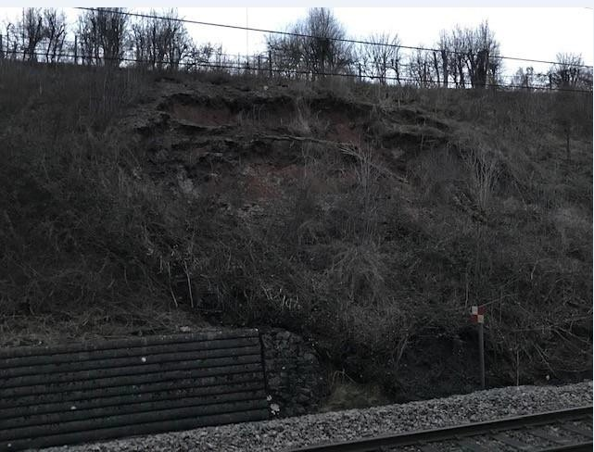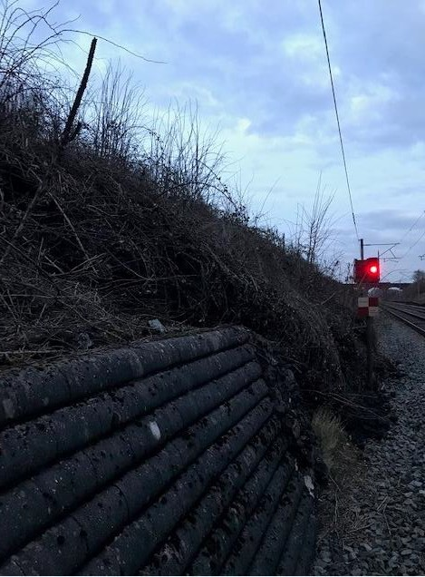

|  |  |  |  |  |  |  |  |
| --- | --- | --- | --- | --- | --- | --- | --- |
| TRUST 760099 IQR5 | | | | | | | |
| Cancelled | 8 | Part Cancelled | 25 | Trains Delayed | 275 | Minutes | 3141 |

***23 FIRES***

None.

***24 WILD REPORTS & HABD ACTIVATIONS***

**Wales and Western (Western) – CCIL 2090417 / North West and Central (WCMLS) – CCIL 2090417** At 1510, 2O80, Great Western Railway, 1453 Worcester Foregate Street - Weymouth, activated Eckington Down Fast line WILD with axle 01 LHS wheel flat, 357kN, level 2 alarm. The train was stopped and the driver advised to proceed at 50mph to destination for RST examination. The vehicle, 58745, as per consist, was taken out of traffic.

|  |  |  |  |  |  |  |  |
| --- | --- | --- | --- | --- | --- | --- | --- |
| TRUST 759955 MEFO | | | | | | | |
| Cancelled | 0 | Part Cancelled | 0 | Trains Delayed | 6 | Minutes | 55 |

## Disconnected Hot Axle Box Detectors:

|  |  |  |  |  |  |  |  |  |  |
| --- | --- | --- | --- | --- | --- | --- | --- | --- | --- |
| *Region / Route* | *Location* | *Line* | *Date Disconnected* | *Reason* | *TOC’s/ FOC’s*  *advised* | *Planned Restoration Date* | *Date Restored* | *Function* | *Fault Number* |
| Eastern (Anglia) | Brentwood | Down Electric | 10/03/16 | Offline | Y | Awaiting update |  | IM | 234632 |
| Eastern (Anglia) | Brentwood | Down Main | 10/03/16 | Offline | Y | Awaiting update |  | IM | 234632 |
| Eastern | Margaretting | Up Main | 19/09/19 |  | Y | Awaiting update |  | IM | 298498 |
| Eastern (EM) | Chiltern Green | Down Slow | 11/07/19 | Defective | Y | Awaiting update |  |  | 148559 |
| Eastern (EM) | Napsbury | Up Fast | 11/07/19 | Defective | Y | Awaiting update |  |  | 148559 |
| Eastern (LNE) | Barkston | Up Main | 01/04/19 | Removed for P’Way work | Y | Awaiting update |  |  |  |
| NW & Central (NW) | Bolton-le- Sands | Up Main | 25/08/19 | Integrity Fault | Y | Awaiting update |  |  | 863361 |
| NW & Central (NW) | Hest Bank | Up Main | 25/08/19 | Integrity Fault | Y | Awaiting update |  |  | 863360 |
| NW & Central (NW) | Low Mill | Down Main | 26/11/14 | Awaiting replacement | Y | Awaiting update |  | IP | 671852 |
| NW & Central (NW) | Sutton Weaver | Down Main |  |  | Y | Awaiting update |  |  |  |
| NW & Central (WCMLS) | Bradnocks Marsh (Coventry) | Up Main | 29/12/19 | Integrity | Y | Awaiting Update |  |  | 872142 |
| NW & Central (WCMLS) | Castlethorpe | Up Fast | 27/11/18 | Error code 6.0 | Y | Awaiting Update |  | IM | 832410 |
| NW & Central (WCMLS) | Harecastle | Up Main | 01/04/19 | Rail incorrectly drilled | Y | Awaiting Update |  |  |  |
| NW & Central (WCMLS) | Penkridge | Up Penkridge | 04/11/19 | Integrity | Y | Awaiting Update |  |  | 870982 |
| NW & Central (WCMLS) | Spetchley |  | 29/12/19 | Integrity | Y | Awaiting Update |  |  |  |
| Wales & Western (Wales) | Dainton | Down Main | 17/11/19 | Defective PC | Y | Awaiting Update |  | IM | 453850 |
| Wales & Western (Western) | Cogload | Down Main | 25/01/20 |  | Y |  |  |  | 458740 |
| Wales & Western (Western) | Treverrin | Down Main | 01/07/19 |  | Y | Awaiting Update |  |  | 443474 |
| Wales & Western (Western) | Twerton | Down Main | 19/11/19 |  | Y | Awaiting Update |  |  | 454030 |
| Wales & Western (Western) | Warminster | Up Salisbury | 22/01/20 | Defective | Y | Awaiting Update |  |  | 458111 |

**Disconnected Wheel Impact Load Detectors:**

|  |  |  |  |  |  |  |  |  |  |
| --- | --- | --- | --- | --- | --- | --- | --- | --- | --- |
| *Region / Route* | *Location* | *Line* | *Date Disconnected* | *Reason* | *TOC’s/ FOC’s*  *advised* | *Planned Restorati on Date* | *Date Restored* | *Function* | *Fault Number* |
| Eastern (LNE) | Sessay | Up Slow | 18/06/2019 | Calibration |  |  |  | IM |  |
| North West & Central (NW) | Heaton Chapel | Up Slow | 30/07/2019 | Calibration |  |  |  | IM |  |
| Southern (Kent) | Sevington | Down Main | 25/04/2018 | PC Failure |  |  |  | IM |  |
| Southern (Kent) | Sevington | Up Main | 09/08/2018 | PC Failure |  |  |  | IM |  |
| Southern (Kent) | Swanley | Up Slow | 02/04/2019 | Calibration |  |  |  | IM |  |
| Scotland | Howwood | Up | 20/01/2019 | HOBC |  |  |  | IM |  |
| Wales & Western (Western) | Urchfont | Up | 11/04/2019 | PC Failure |  |  |  | IM |  |
| Wales & Western (Western) | Urchfont | Down | 11/04/2019 | PC Failure |  |  |  | IM |  |

***25 GROUP STANDARDS GE/RT8250 & GO/RT3350***

None.

***26 TPWS***

|  |  |  |  |  |  |  |  |  |
| --- | --- | --- | --- | --- | --- | --- | --- | --- |
| ***Region*** | ***Route*** | ***Train*** | ***Signal/PSR/ Buffer Stop*** | ***Line/Platform*** | ***Location*** | ***Speed (reported)*** | ***Speed (set)*** | ***CCIL*** |
| Southern | Wessex | 1P18, South Western Railway, 0710 Havant – London Waterloo | WZ202 | Up Main | Godalming | Not specified | 45 | 2090228 |
| Scotland | Scotland | 5M71, ScotRail, 0507 Motherwell TMD - Newton | GMN171 | Down Main | Newton East Junction | 20 mph | 34.5 | 2090167 |
| NW&C | NW | 1U93, Northern, 0746 Barrow – Manchester International Airport | MP272 | Up Airport | Heald Green West Junction | 29.84 mph | 25.5  mph | 2090300 |
| Easern | EM | 1L54, CrossCountry, 1922 Birmingham – Stanstead Airport | PSR | Up Nuneaton | Wigston Glen Parva Junction | 80 mph | 83 mph | 2090535 |

***27 MISCELLANEOUS***

## Eastern (Anglia) – CCIL 2090327

At 1137 the driver of 6V12, Freightliner, 1054 Chelmsford – Acton Yard, reported a possible dragging brakes on the second and third vehicles back from the locomotive, VTG3457 and VTG3424. The train was held in the Channelsea Loop to allow the driver to examine the train, trapping a number of freight services in rear. A Mobile Operations Manager and fitters were sent to site. 4E25, DB Cargo, 1129 Bow Depot – Heck, which was trapped in rear on the Down Temple Mills line, was moved to the Temple Mills Loop to run round and clear the running lines. By 1213 the driver had been able to release one set of brakes but was unable to release a second set. The fitter arrived on site at 1426 and was able to isolate the affected wagon, allowing the train to continue, 189 mins late.

|  |  |  |  |  |  |  |  |
| --- | --- | --- | --- | --- | --- | --- | --- |
| TRUST 759393 MDBH | | | | | | | |
| Cancelled | 0 | Part Cancelled | 2 | Trains Delayed | 98 | Minutes | 1173 |

|  |  |  |
| --- | --- | --- |
| ***INCIDENT*** | ***TODAY’S TOTAL*** | ***DAYS SINCE LAST INCIDENT*** |
| **PASSENGER ACCIDENTAL FATALITIES** | **0** | **430** |
| **RAILWAY WORKFORCE FATALITIES** | **0** | **56** |
| **SIGNALS PASSED AT RED (CATEGORY ‘A’)** | **0** | **1** |
| **SIGNALS PASSED AT DANGER (ERROR/TECHNICAL SIGNAL REVERSION)** | **1** | **0** |
| **DERAILMENTS** | **1** | **0** |
| **TRAIN COLLISIONS** | **1** | **0** |
| **TRAINS STRIKING ROAD VEHICLES** | **0** | **11** |
| **ENVIRONMENTAL INCIDENTS** | **0** | **2** |

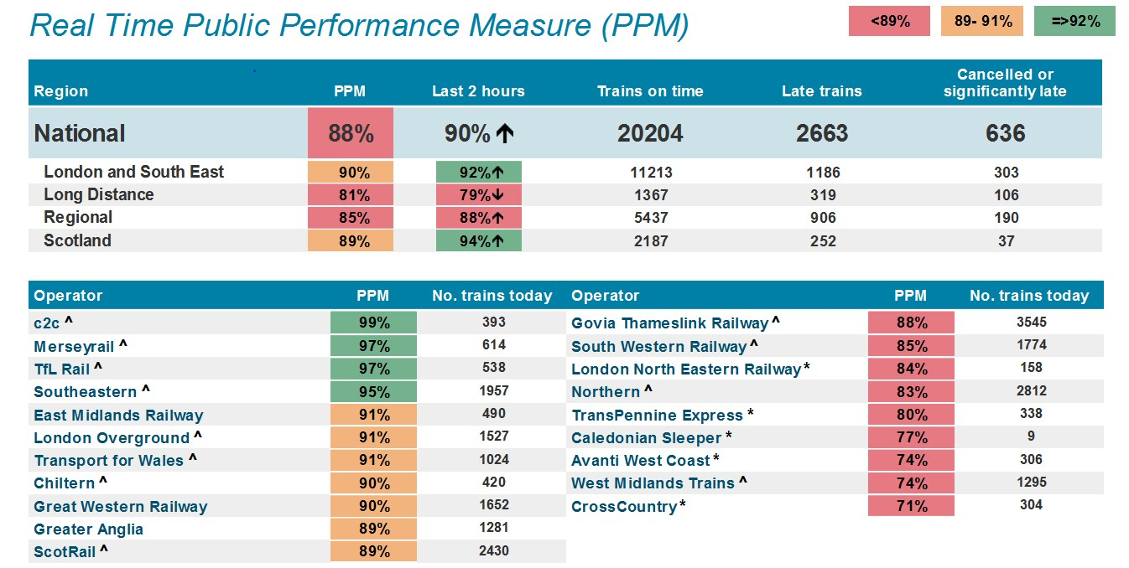

***Open Access Operators***

